Prediction of Breast Cancer Relapse Using Gene Expression Data and Deep Learning
Aavash Pant
George Mason University
BINF 761: Machine Learning for Bioinformatics
Instructor: Dr. Christopher Lockhart
May 5, 2026

Abstract
The project, “Prediction of Breast Cancer Relapse Using Gene Expression Data and Deep Learning”, is about the use of machine learning methods to predict breast cancer relapse. This is done using gene expression data. The gene expression data from the NCBI database called the GSE2034 was used. But due to its high dimensionality and complexity, 1D Convolutional Neural Network (CNN) was implemented. CNN's ability to find distinct patterns between genes made it the ideal choice. The dataset also had to go through multiple preprocessing steps, like normalization, and merging of the clinical outcome labels. The model was created and evaluated using accuracy, precision, recall, F1-score, and ROC-AUC. The overall results showed that the model was able to have a strong classification, but it did suffer with weak recall values. The results showed that the use of CNN model was effective in capturing gene expression patterns with its overall high accuracy, precision, and ROC-AUC. This indicated that the model had a strong performance and captured the underlying patterns in the dataset. But due to its low recall values, the model lacked the ability to find all true relapse cases. This could be due to the imbalance of the dataset and would need further improvements for the model to be perfect. The CNN model was very effective, but there is a need for further improvements to enhance sensitivity in relapse prediction.

Introduction

Breast cancer is one of the more prevalent forms of cancer that is seen in women. Females must consistently get annual checkups to make sure that their breast cells are healthy and to assess the risk of cancer. Even though it is extremely prevalent and requires yearly checkups, a large population of women still must fight the breast cancer battle. Despite advances in early detection and treatment, a significant challenge remains in understanding which patients are at higher risk of disease progression and recurrence. Predicting disease relapses is a critical challenge in clinical decision-making, which makes it important to develop an accurate model that can identify the risk of relapse before it happens and to provide the support needed the patient requires (World. “Breast Cancer.”). Advancement is different techniques, such as RNA sequencing and microarrays, have been used to understand genes and whole genome sequences, providing more insight into disease progression. It still cannot accurately predict when a patient might relapse. Machine learning models have also been used, yet traditional machine learning methods often struggle to fully grasp the amount of complexity of the data, so the use of a more complex neural network was a very attractive choice (Warning).
The neural network that was implemented was a 1D Convolutional Neural Network, as it can efficiently learn hierarchical feature representations from high-dimensional data while reducing the number of parameters compared to fully connected models. Even though CNN is mostly used in image-related data and image processing, the idea behind using it with gene expression data was to capture the local patterns and interactions between genes. The hierarchical nature of CNN allows it to combine with simple patterns, which can then be explored in more abstract representations in deeper layers. The use of CNN also allows the model to automatically learn the gene interaction without requiring any input, which is an extremely important skill because the features exceed the number of samples. This advantage allows CNN to focus on important regions of the gene expression while ignoring irrelevant noise. This approach can allow for greater understanding of biological relationships that are not easily captured by traditional models (Nasir et al.). Further improvements can also be made to the model so that can further improve the performance and the results. All these factors make CNN a great choice, and a powerful tool to use for this project. In this study, a 1D CNN was used to predict relapse outcomes in breast cancer patients using gene expression data. The goal was to evaluate whether deep learning can improve predictive performance and better identify patients at risk of relapse. With the combination of computational methods and genomic data, this approach aims to contribute to the field of medicine, and the predictive model can be used for personalized treatment and decision making.

Methods

For this study, the dataset that was used was collected from the NCBI Gene Expression Omnibus (GEO) database from the repository GSE2034. This dataset contains the gene expression profiles from patients who have had breast cancer, along with associated clinical outcomes. The dataset includes 286 breast cancer patients, consisting of 180 lymph node-negative patients who remained relapse-free and 106 patients who developed distant metastasis (relapse). The main objective of this project is to build a supervised machine learning model that can predict breast cancer relapses. This was done through binary classification, where the patients were given a number 0 (for non- relapses) and 1 (for relapses) in the clinical outcome data.
​ The dataset has thousands of other gene features that were generated through a microarray-based expression profiling, measuring thousands of genes simultaneously for each patient. Because of this, the dataset had to go through multiple steps of preprocessing. The first being that the dataset was transformed and merged into one. This made the dataset more suitable for machine learning standards. This was achieved by converting the gene expression matrix into a structured format where gene identifiers (ID_REF) were set as row indices and the dataset was transposed so that each row represented an individual patient and each column represented a gene feature. Then, the dataset that contained relapse outcomes was merged with the gene expression data using shared sample identifiers to ensure proper alignment between features and labels. Some other preprocessing steps included making all the dataset numeric, working with missing values through removal, and normalization to make sure that data scaling is similar across the dataset.
​ A 1D- Convolutional Neural Network (CNN) was implemented using PyTorch, as PyTorch is the best structure and framework for deep learning models. The input consists of the preprocessed gene expression data, that was variables (X) and corresponding labels (y). The feature matrix represented gene expression levels for each patient, while the labels indicated whether the patient experienced relapses or not. The architecture began with two sequential CNN layers transforming the input into 32 feature maps using a kernel size of 5 with padding to preserve dimensionality. The second layer consisted of increasing the depth to 64 feature maps, and each layer was followed by ReLU activation. A max pooling layer was applied to reduce the dimensionality, and a dropout layer with a rate of 0.3 was included after the fully connected layer. The output was then flattened and passed into a fully connected layer with 128 neurons. A sigmoid activation was then applied during evaluation to convert logits into probabilities for binary classification.
​ The model was then trained using the binary cross-entropy loss function with logits (BCEWithLogitsLoss) with optimization that was also applied using the Adam optimizer with a learning rate of 0.0001 and a weight decay rate of 0.001, and regularization to improve generalization. Together with dropout layers in the architecture, these regularization techniques helped improve the model’s generalization ability when applied to unseen test data. The model was evaluated using Accuray, Precision, recall, F1-score, and AUCROC, along with a loss curve and a ROC curve.

Results
The results of the CNN were moderate in predicting breast cancer relapses using gene expression data. The model showed a very good ROC-AUC score, which showed that the model was good at distinguishing between non-lapse and relapse cases. The precision was also very high, which showed that the model was very effective in predicting relapse cases. The accuracy was also very high, which again showed that the model was very good at being predictive. But one issue with the model was the recall score. The recall score was relatively low; the model failed to identify a substantial number of true relapse cases. This imbalance resulted in a lower F1-score, reflecting the trade-off between precision and recall.

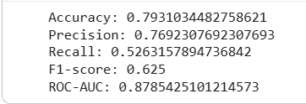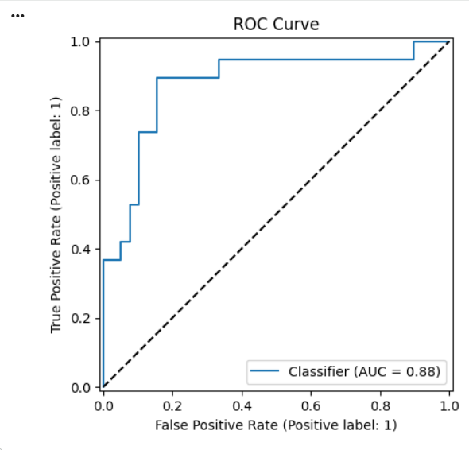
The figure above shows the full results of the model and the ROC curve. The Accuracy score was 0.79, the Precision score was 0.77, the recall score was 0.53, the F1- score was 0.625, and the ROC-AUC score was 0.88. The model showed that overall, it was very capable of distinguishing between non-relapse and relapse cases. The ROC curve also confirmed the findings of the model, showing a clear separation from the diagonal baseline, indicating strong discriminative ability between relapse and non-relapse classes.

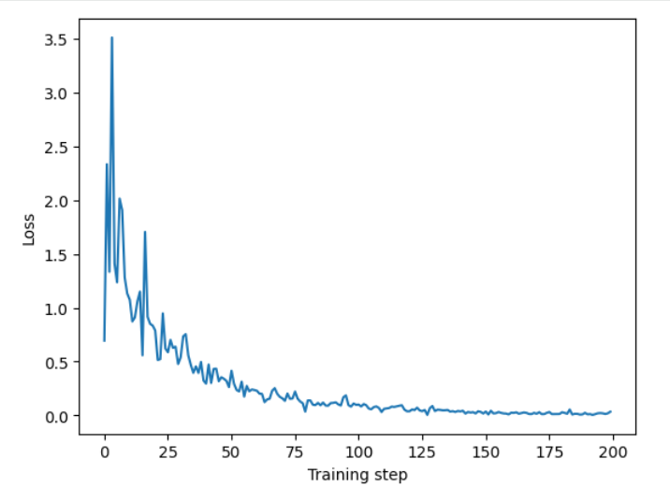
The figure above is the training loss curve. This figure shows that the curve showed a rapid decrease in loss during the early training steps, followed by a gradual stabilization as training progressed. This showed that the model was able to learn patterns without a lot of instability.
Based on the findings throughout the model, it can be concluded that the model was very good at being able to capture patterns, as reflected by the high ROC-AUC and solid accuracy. The high precision score also indicates that the model can predict relapses, but the low recall scores indicate that the model failed to identify nearly half of the actual relapse cases. The model was very biased in being able to predict the non-relapsed cases, which could be because of the lack of balance in the overall data. This finding is further confirmed by the loss curve and the ROC curve, that the model was very effective in the learning phase, but the low recall score is a critical limitation: the model is not sufficiently sensitive to detecting relapse cases.
There were some studies with high accuracy and low recall. The research paper, “Precision and recall oncology: combining multiple gene mutations for improved identification of drug-sensitive tumors,” focuses a lot on trying to improve the recall values. This is because of the complexity and high dimensionality of gene expression data. This can lead to imbalanced performance across evaluation metrics, including reduced recall value (Naulaerts, Stefan, et al.).
The main limitations of this project are its low recall value, which does require a lot of improvements. The next limitation of this project is that the case only uses 286 patients, which is relatively low. CNN architecture is also very simple; it is not extensively complex and restricts its ability to capture long-range gene interactions. Furthermore, no external validation dataset was used, so the model’s performance on independent data remains unknown. The model requires extensive improvement, especially with the recall. A lot of changes were implemented to improve the recall, but each time they were implemented, the accuracy and precision score decreased. So, for a proper improvement, the model needs to be able to have a high precision/ accuracy and a high recall value for it to be complete. The architecture would need to be deeper and more complex for this to be achieved, and incorporating biological knowledge, such as gene pathways, or applying feature selection methods could reduce noise and improve both interpretability and predictive performance.

Conclusion
In conclusion, the project aimed to find patterns and decide whether a patient will have cancer relapsed. This was done through the use of high dimensional data from the NCBI, called the data GSE2034. 1D- Convolutional Neural Network (CNN) was implemented to capture patterns and relationships between genes, and the results showed that the model was very effective in learning patterns. The model showed strong accuracy, ROC-AUC score, and also showed a great score in precision. These results showed that the model was very reliable in prediction when dealing with relapsed cases, but the low recall score showed that the true number of relapsed cases were not detected. This was a major limitation of the model, which is one of the key improvements that needs to be made. The model was very good at learning patterns and was also very good at predicting the relapses. The findings through the CNN model were a very promising approach, and key improvements can make the model even better. Future works could focus on improving recall and trying to make the model more complex or deeper neural network architectures to better capture gene interactions. In conclusion, the model did demonstrate a good ability to learn, and the results were very promising. This also aligned with prior research showing the effectiveness of deep learning in genomics, further refinement is necessary to improve sensitivity and enhance its applicability in real-world clinical decision-making.

Bibliography

World. “Breast Cancer.” Who.Int, World Health Organization: WHO, 16 Apr. 2026, https://www.who.int/news-room/fact-sheets/detail/breast-cancer. Accessed 5 May 2026.
Warning. “Breast Cancer: Symptoms, Types, Causes & Treatment.” Cleveland Clinic, 5 Sept. 2023, https://my.clevelandclinic.org/health/diseases/3986-breast-cancer. Accessed 5 May 2026.
Nasir, Faizan, et al. “Breast Cancer Detection Using Convolutional Neural Networks: A Deep Learning-Based Approach.” Cureus, Springer Science and Business Media LLC, May 2025, https://doi.org/10.7759/cureus.83421. Accessed 5 May 2026.

Naulaerts, Stefan, et al. “Precision and Recall Oncology: Combining Multiple Gene Mutations for Improved Identification of Drug-Sensitive Tumours.” Oncotarget, vol. 8, no. 57, Impact Journals, LLC, Sept. 2017, pp. 97025–40, https://doi.org/10.18632/oncotarget.20923. Accessed 4 May 2026.
‌

